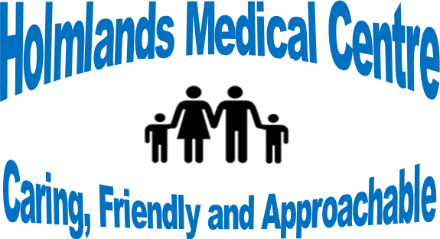

Venue: Holmlands Medical Centre
Holmlands Medical Centre Patient Participation Group meeting – 12.1.23
Present: Dr. P. Srivastava (GP Partner) N Srivastava (GP Partner) Rachel Kavanagh (Practice Manager)
PPG Members: Jim Ainsworth (Chair), Ann Parry, Susan Davies, Paul Brady, Norman Warhurst
Apologies: Jennifer Pierce, Colin Derby, Dr. Bala Sridha

Apologies:
- Welcome to all

- Minutes from previous meeting:
RK reported that the web site had been updated since the last meeting.

- PCN (Primary Care Network) ACTIVITIY
The PPG were informed of the ongoing additional roles being provided to HMC via PCN: We now have Paramedics in house, with recurrent sessions, seeing patients with acute conditions and also assisting in accommodating patients. This has helped with winter pressures. An Acute Respiratory Hub is a new clinic available via online appointments at the Miriam Medical Centre, this is available to all Wirral Wide GP practices with daily appointments for respiratory symptoms. The home visit service also continues, with paramedics going to see unwell patients unable to get out of house, to assess and stabilise or arrange admission if necessary. NS suggested that as a practice we should obtain competencies lists for the in-house paramedics and check how the patients are followed up from their consultation.

- PRACTICE PERFORMANCE
Discussed the results for the practice feeding back from ‘Friends and Family’ testing with >96% results consistently. Comments from patients continue to give praise, and a new patient had given a google review of her experience about registration with HMC staff. CQC continue to monitor the practice with no planned date set for visit. PPG Members were given a copy from the F+F results, via iplato, for December 2023

- CQC Inspections/Quality Care
2023 CQC visit is expected.

- LEASE/GRANT/BUILDING
The Lease has been approved and is still with the District Valuer for market valuation. A meeting to discuss is planned. The PPG were informed this was still delaying any improvement grant. The partners are having discussions about installing solar panels to address rising energy bills.

- STAFFING
GP 3rd year students are attending the practice for 4 weeks and gaining experience from working with the HMC clinical team. The Office Manager, Erica, is due to take maternity leave from on 1.3.23. To cover, 1 candidate, who seems very good, has been interviewed. The post has been advertised, via the NHS, with a closing date of 16.1.23.

- Electronic consultation. It’s use had freed up the time of 20 appointments per week, but it was recognised that that it was not suitable for patients who are not IT savvy. Hence information was available about other appointment options either on-line or by recorded answer phone messages.

- Date of next meeting: TBC.

